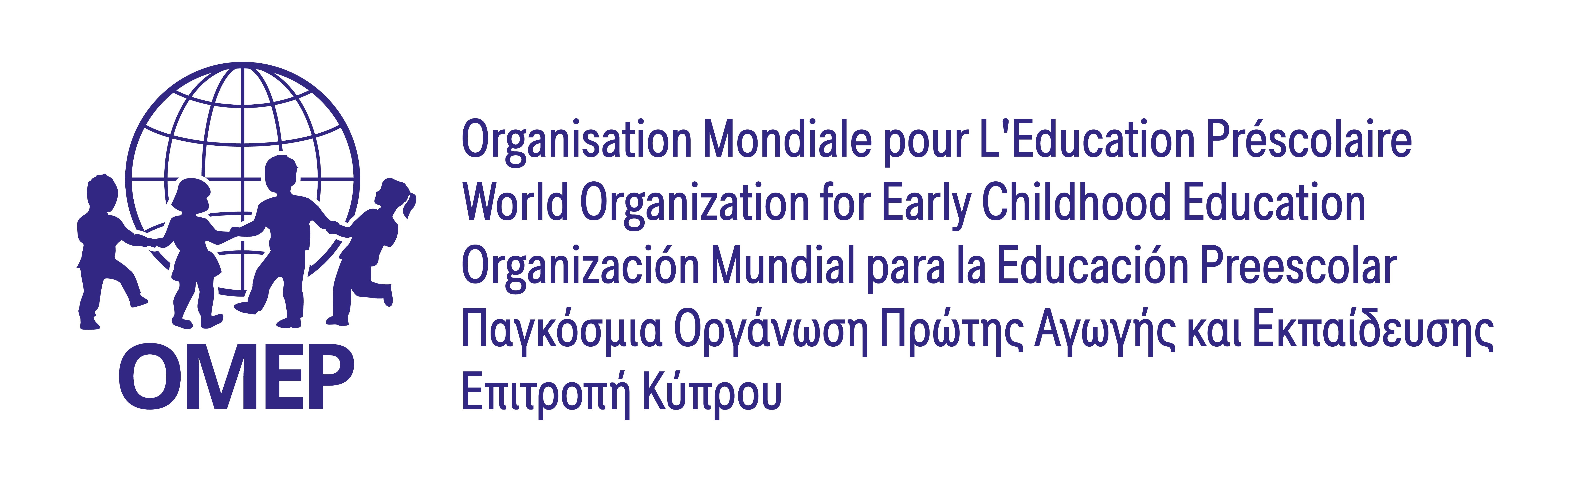

European OMEP Conference 2023
“Quality and Equality in Early Childhood Education and Care”

FORM FOR SUMMARY PROPOSAL Deadline 28/2/2023
Title:

Speaker / Moderator:

Function, position:
Organization you represent:

Email address:

Phone / mobile:

Postal address:
Type of presentation: | Oral Communication | Workshop | Poster | Good Practices | Symposium
Theme of the Congress Topics | Number | Theme Tittle:  P
Summary strictly
350-400 words

Special Equipment if needed
Date completed

